**DESIGN AND IMPLEMENTATION OF IDENTITY CARD VERIFICATION SYSTEM WITH QUICK RESPONSE CODE**

# TITLE PAGE

**BY**

**BITRUS VICTOR**

**(ST/CS/ND/23/061)**

**DEPARTMENT OF COMPUTER SCIENCE,**

**SCHOOL OF SCIENCE AND TECHNOLOGY,**

**FEDERAL POLYTECHNIC, MUBI, ADAMAWA STATE.**

**IN PARTIAL FULFILLMENT OF THE REQUIREMENT FOR THE AWARD OF NATIONAL DIPLOMA (ND) IN COMPUTER SCIENCE.**

**JULY, 2025**

# DECLARATION

I hereby declare that the work in this project titled “**Design and Implementation of Student Identity Card Verification System with Quick Response Code”** was performed by me under the supervision of Mal. Usman Wakili. The information derived from literature has been duly acknowledged in the text and a list of references provided. The work embodied in this project is original and has not been submitted in part or in full for any other diploma or certificate of this or any other institution.

Bitrus Victor ________________ _______________

(ST/CS/ND/23/061) Signature Date

# CERTIFICATION

This project titled “**Design and Implementation of Student Identity Card Verification System with Quick Response Code”** meets the regulations governing the award of National Diploma (ND) in Computer Science, Federal Polytechnic Mubi, Adamawa State

Mal. Usman Wakili Sudi __________________

(Project Supervisor) Sign/Date

Mr. Mustapha Kassim. __________________

(Head of Department) Sign/Date

Mal. Abdulrahman Saidu _________________

(External Examiner) Sign/Date

# DEDICATION

This project is dedicated to my beloved parents and love ones for their advice, encouragement and financial support towards my academic pursuit.

# ACKNOWLEDGEMENTS

I want to acknowledge Almighty God for His infinite mercy and protection throughout my academic journey and for granting me the understanding to achieve success in my studies.

I also recognize my supervisor, Mal. Usman Wakili Sudi, who took time, despite his busy schedule, to guide and direct me throughout this research work.

I extend my gratitude to the Head of the Computer Science Department, Mal. Mustapha Kassim, for his moral encouragement during my period of study. I also acknowledge all the staff of the Computer Science Department for their support, encouragement, and the knowledge they have imparted to me throughout my studies.

I deeply appreciate my beloved parents for their love, care, and for providing me the opportunity to be educated and achieve my dreams.

Finally, I am thankful for the efforts of my uncles and aunties for their encouragement and support throughout the course of my study, as well as my friends, relatives, course mates, and all well-wishers. I love you all. May Almighty God bless you abundantly. Amen.

# TABLE OF CONTENTS

TITLE PAGE i

DECLARATION ii

CERTIFICATION iii

DEDICATION iv

ACKNOWLEDGEMENTS v

TABLE OF CONTENTS vi

LIST OF FIGURES viii

LIST OF TABLES ix

ABSTRACT x

CHAPTER ONE 1

INTRODUCTION 1

1.1 Background to the Study 1

1.2 Problem Statement 2

1.3 Aim and Objectives 2

1.4 Significance of the Study 2

1.5 Scope of the Study 3

1.6 Definition of Some Operational Terms 3

CHAPTER TWO 5

LITERATURE REVIEW 5

2.1 Introduction 5

2.2 Computerized Systems in Educational Institutions 5

2.3 ID Card Processing Systems in Educational Institutions 6

2.4 Related Studies 7

2.5 Information System 9

2.6 Summary 10

CHAPTER THREE 11

SYSTEM DESIGN AND ANALYSIS 11

3.1 Introduction 11

3.2 Disadvantages of the Existing System 11

3.3 Advantages of the Proposed System 11

3.4 Software Development Model 12

3.5 Method of Data Collection 13

3.6 System Design 13

3.6.1 Algorithm Diagram 13

3.6.2 System Architecture 14

3.6.3 Database Tables/Queries Structures 14

3.6.4 Input and Output Design 15

3.7 System Requirements Specification 17

3.7.1 Hardware Requirements 17

3.7.2 Software Requirements 17

3.7.3 Personnel Requirement 17

CHAPTER FOUR 18

RESULTS AND DISCUSSION 18

4.1 Introduction 18

4.2 Results 18

4.3 Discussion 21

4.4 User manual 22

4.4.1 System Installation 22

4.4.2 System operational guide 22

CHAPTER FIVE 23

SUMMARY, CONCLUSION AND RECOMMENDATIONS 23

5.1 Summary 23

5.2 Conclusion 23

5.3 Recommendations 23

REFERENCES 25

APPENDIX A 27

APPENDIX B 30

# LIST OF FIGURES

Figure 3.1: Waterfall model - - - - - - - - 12

Figure 3.2: Use case diagram- - - - - - - - 13

Figure 3.3: System Architecture - - - - - - - - 14

Figure 3.4: Add Student Form- - - - - - - - 15

Figure 3.5: Login form - - - - - - - - 15

Figure 3.6: Bulk Print - - - - - - - - 15

Figure 3.7: Student Report - - - - - - - - 16

Figure 3.8:ID Card report - - - - - - - - 16

Figure 4.1: Welcome Interface - - - - - - - 18

Figure 4.2: Login interface - - - - - - - - 18

Figure 4.3: Add Student Details - - - - - - - 19

Figure 4.4: Students Records Interface- - - - - - - 19

Figure 4.5: Print Bulk Interface - - - - - - - 20

Figure 4.6: ID Card interface - - - - - - - - 20

# LIST OF TABLES

Table 1: Student details- - - - - - - - - 14

Table 2: Admin - - - - - - - - - 14

# **ABSTRACT**

*This project focuses on the design and implementation of a ID card verification system with QR code for the Federal Polytechnic, Mubi. The motivation for the project stems from the challenges associated with manual ID card processing, including delays, inaccuracies in student records, and difficulties in managing large volumes of data. The developed system automates the entire ID card issuance process, providing a user-friendly interface for administrators and staff to manage student details efficiently. The system consists of several key interfaces: Welcome Interface, Login Interface, Add Students Details, Students Records Interface, Print Bulk, and ID Card Interface. Each interface is designed to streamline tasks, from entering and storing student information to printing ID cards in bulk. The system also incorporates security features to ensure that sensitive student data is protected. The project successfully addresses the inefficiencies of the manual system, reducing processing time, minimizing errors, and enhancing overall administrative efficiency. The implementation of this system at the Federal Polytechnic, Mubi, demonstrates the potential of technology to improve educational administration processes. This work contributes to the field by providing a practical solution that can be adapted and scaled for use in other educational institutions. Recommendations for future enhancements include the integration of biometric authentication, development of a mobile application, and expansion of the system’s capabilities to support larger institutions. The project concludes that the computerized ID card processing system is a valuable tool for modernizing student administration at the Federal Polytechnic, Mubi.*

# CHAPTER ONE

# INTRODUCTION

## 1.1 Background to the Study

The Federal Polytechnic, Mubi, has traditionally relied on manual methods for processing student identification (ID) cards. This approach, which involves physical paperwork and manual data entry, has been plagued with inefficiencies, errors, and security concerns. In recent years, institutions worldwide have transitioned to digital solutions to streamline administrative processes, ensuring accuracy, efficiency, and enhanced security. The integration of QR code technology into ID card systems represents a significant advancement, enabling institutions to improve verification processes and data management.

A computerized ID card generating system with QR codes automates the creation, management, and verification of student IDs. This system ensures that each student’s data is securely stored in a centralized database while allowing quick authentication through QR scanning. Studies by Rodrigues *et al.* (2021) have shown that computerized systems enhance operational efficiency and reduce processing time in educational institutions. Furthermore, QR codes offer a cost-effective and secure method for storing and retrieving information, supporting real-time authentication and minimizing identity fraud (Alharthi *et al.,* 2020).

The integration of QR codes into student ID cards provides several advantages. Unlike traditional barcodes, QR codes store more data and can be easily scanned using smartphones or dedicated scanners, ensuring fast and reliable verification. Institutions can use this technology for attendance tracking, library access, and secure campus entry. Johnson & Roberts (2021) highlight that digital authentication methods improve institutional security and reduce the likelihood of unauthorized access.

Additionally, QR code-based ID card systems align with global digitalization trends, improving service delivery and reducing administrative burdens. A study by Davis and Wong (2021) found that students expect quick and accurate administrative services, which are difficult to achieve with manual processes. By adopting a computerized ID card system with QR code integration, the Federal Polytechnic, Mubi, can significantly enhance its operational efficiency, security, and overall student experience.

Furthermore, computerized ID systems contribute to environmental sustainability by reducing paper usage, aligning with global efforts to minimize carbon footprints (Kim & Park, 2019). This transition ensures that the institution remains competitive, technologically advanced, and capable of meeting the evolving needs of students and staff.

1.2 Problem Statement

The current manual system for processing student ID cards at the Federal Polytechnic, Mubi, presents several challenges:

Time-Consuming: The manual process involves multiple steps, leading to delays in issuing ID cards.

Prone to Errors: Human errors in data entry and processing result in inaccurate ID cards.

Security Concerns: Manual records are susceptible to loss, theft, and unauthorized access.

Limited Functionality: Traditional ID cards do not support advanced authentication features, making verification processes cumbersome.

Resource-Intensive: The manual system requires significant human effort and material resources.

These limitations necessitate the development of a computerized ID card generating system with QR code technology to improve efficiency, security, and accessibility.

## ****1.3 Aim and Objectives****

The aim of this study is to design and implement a computerized ID card verification system with QR code. The specific objectives are:

1. To develop a user-friendly interface for inputting student information.
2. To create a secure database for storing and managing student records.
3. To integrate QR code technology into the ID card system for enhanced security and verification.
4. To design a system capable of automatically generating and printing student ID cards.

## ****1.4 Significance of the Study****

The significance of this study lies in its potential to modernize the student ID card processing system at the Federal Polytechnic, Mubi, benefiting various stakeholders:

Students will benefit significantly from the implementation of the ID card generating system with QR code technology. The automation of the process ensures that students receive their ID cards promptly, minimizing administrative delays and enhancing their overall experience. This efficiency eliminates long waiting times and ensures that students can access institutional services without unnecessary hindrances.

For administrative staff, the adoption of this system alleviates the burden of manual data entry and card issuance, allowing them to focus on other critical responsibilities. Automation streamlines workflows, improves accuracy, and enhances productivity by reducing the risk of human error. Additionally, QR code integration strengthens institutional security by providing a reliable authentication mechanism, effectively minimizing identity fraud and unauthorized access to facilities.

Beyond the immediate institutional benefits, this system sets a precedent for other educational institutions seeking to modernize their administrative operations. By demonstrating the advantages of digital ID card processing, the system can inspire broader adoption of similar technological advancements. Furthermore, the reduction in paper usage contributes to environmental sustainability, aligning with global efforts to promote eco-friendly administrative practices.

## **1.5 Scope of the Study**

This study focuses on the design and implementation of a computerized ID card generating system with QR codes for the Federal Polytechnic, Mubi. It involves an in-depth analysis of the existing manual system and its inefficiencies, highlighting the need for a more efficient, accurate, and secure approach. The development of this system includes key components such as a user-friendly interface for student data entry, a secure database for managing student records, and a QR code generation feature to enhance authentication and verification processes.

Additionally, the study incorporates an automated ID card generation and printing module, ensuring seamless and quick issuance of ID cards. Security protocols are integrated to safeguard student information, mitigating risks associated with data breaches and unauthorized access. The system undergoes rigorous testing and evaluation to compare its performance with the manual process, assessing its impact on efficiency, accuracy, and overall security improvements.

## **1.6 Definition of Some Operational Terms**

**Authentication**: The process of verifying an individual’s identity using secure digital methods (Kim & Park, 2019).

**Biometric Verification:** A security process that uses unique biological characteristics such as fingerprints or facial recognition to confirm an individual's identity (Zhao et al., 2022).

**Computerized System**: A digital system that automates tasks previously performed manually, improving efficiency and accuracy (Rodrigues et al., 2021).

**Data Integrity:** The accuracy, consistency, and reliability of data throughout its lifecycle, especially during input, processing, and storage (Olawale *et al.,* 2023).

**Database**: A structured collection of electronic data, organized for efficient retrieval and management (Johnson & Roberts, 2021).

**Encryption:** The process of converting information into a secure format to prevent unauthorized access during storage or transmission (Singh & Patel, 2021).

**ID Card Processing**: The process of creating, managing, and distributing identification cards within an institution (Davis & Wong, 2021).

**Management**: The coordinated planning, organizing, and controlling of resources to achieve institutional goals (Lunenburg, 2021).

**QR Code**: A machine-readable code that stores data and enables quick retrieval through scanning, commonly used for authentication and verification (Alharthi et al., 2020).

**System Security:** The protective measures and protocols implemented to safeguard software and hardware from threats such as unauthorized access, data breaches, and malware (Chen & Lee, 2022).

**User Interface (UI):** The visual layout through which users interact with a computerized system, including screens, menus, and icons (Anderson & Taylor, 2022).

# CHAPTER TWO

# LITERATURE REVIEW

## 2.1 Introduction

This chapter presents a comprehensive review of literature relevant to the design and implementation of computerized student ID card processing systems in educational institutions. The literature review is structured around key themes, including the benefits of computerized systems, challenges in manual ID card processing, and best practices in system design and implementation.

## 2.2 Computerized Systems in Educational Institutions

Computerized systems play a pivotal role in transforming administrative processes within educational institutions, offering a wide array of benefits across various functional areas. One significant advantage is the enhancement of operational efficiency. By automating routine tasks such as data entry, processing, and retrieval, computerized systems streamline administrative workflows, saving time and resources. This efficiency gain allows administrative staff to focus on value-added activities such as student support services and strategic planning (Ferdousi *et al*., 2020).

Moreover, computerized systems facilitate better data management and decision-making. Through centralized databases and integrated reporting tools, institutions can access timely and accurate information for planning, monitoring, and evaluation purposes. Real-time data analytics enable administrators to identify trends, assess performance, and make informed decisions to improve institutional effectiveness (Tsolakidis & Kartakoullis, 2019).

Another significant benefit of computerized systems is the improvement of service quality and student satisfaction. By providing seamless access to information and services through user-friendly interfaces, institutions can enhance the overall student experience. Automated processes reduce wait times, minimize errors, and ensure consistency in service delivery, leading to higher levels of satisfaction among students and other stakeholders (Yi & Hwang, 2018).

Furthermore, computerized systems contribute to institutional agility and innovation. By leveraging emerging technologies such as artificial intelligence, machine learning, and data analytics, institutions can develop innovative solutions to address complex challenges and seize new opportunities. These technologies enable predictive modeling, personalized learning experiences, and adaptive decision support systems, fostering a culture of innovation and continuous improvement (Alrajawy *et al*., 2021).

## 2.3 ID Card Processing Systems in Educational Institutions

ID card processing systems play a crucial role in ensuring the security, efficiency, and effectiveness of operations within educational institutions. These systems encompass a range of processes, from capturing and storing student information to issuing and managing identification cards. In today's digital age, the implementation of computerized ID card processing systems has become increasingly common, offering numerous benefits over traditional manual methods.

One significant advantage of computerized ID card processing systems is the enhancement of security. By integrating advanced security features such as biometric authentication, encryption, and access controls, institutions can safeguard sensitive student information and mitigate the risk of unauthorized access or identity theft (Alotaibi *et al*., 2021). Additionally, digital systems allow for centralized management of access privileges, enabling administrators to revoke or modify permissions quickly and efficiently in case of lost or stolen cards.

Moreover, computerized ID card processing systems improve operational efficiency by automating routine tasks and streamlining workflows. Through barcode or RFID technology, these systems enable swift identification and verification of students, staff, and visitors, reducing waiting times and enhancing overall productivity (Saini & Grewal, 2020). Furthermore, digital databases facilitate seamless integration with other institutional systems, such as attendance tracking and library management, enabling real-time data sharing and analysis for improved decision-making (Rocha *et al*., 2021).

Another significant benefit of computerized ID card processing systems is the enhancement of service quality and user experience. By providing self-service kiosks or online portals for ID card requests and renewals, institutions empower students and staff to manage their identification needs conveniently and independently. This self-service approach reduces administrative burden and enhances satisfaction levels among users, leading to a more positive overall perception of institutional services (Liu & Huang, 2019).

Furthermore, computerized ID card processing systems support sustainability initiatives by reducing paper usage and promoting environmentally friendly practices. By digitizing ID card issuance and management processes, institutions minimize their ecological footprint and contribute to conservation efforts (Leal *et al*., 2021). Additionally, digital systems facilitate remote access and online transactions, reducing the need for physical presence and transportation, thereby further reducing carbon emissions and promoting eco-friendly behaviors.

## 2.4 Related Studies

Rodrigues, Silva, and Oliveira (2018), investigated the impact of computerized systems on administrative efficiency within educational institutions. Their study revealed that automation significantly reduces the time required for processing tasks, such as ID card issuance, which enhances overall operational efficiency. The research emphasized the importance of integrating such systems to streamline administrative workflows and minimize human error.

Smith, Brown, and Wilson (2019), focused on the security enhancements provided by computerized systems in educational settings. Their study highlighted the implementation of encryption and secure access controls in computerized ID card processing systems, which protect against unauthorized access and data breaches. The findings underscore the critical role of robust security measures in safeguarding sensitive student information.

Alharthi *et al.* (2020), explored the broader implications of digital transformation in higher education. Their research identified computerized systems as key enablers of this transformation, facilitating improved data management, decision-making, and service delivery. The study provides a framework for assessing the maturity of digital initiatives within educational institutions.

Johnson and Roberts (2021), examined the challenges associated with manual student services and the potential of computerized systems to address these issues. Their study revealed that automation not only improves efficiency but also reduces errors and administrative burdens. They recommended adopting computerized systems to enhance service quality and operational effectiveness.

Davis and Wong (2021), investigated student expectations and experiences with administrative services in higher education. Their research showed that students prefer digital solutions for administrative tasks, including ID card processing, due to their convenience and reliability. The study highlighted the positive impact of computerized systems on student satisfaction and institutional reputation.

Kim and Park (2019), studied the environmental benefits of adopting digital solutions in educational administration. They found that computerized ID card processing systems significantly reduce paper usage and contribute to sustainability goals. Their research emphasized the role of technology in promoting eco-friendly practices within educational institutions.

Azeez, Khalid, and Yusuf (2022) explored strategies for future-proofing educational administration through technology integration. Their study identified the need for adaptable and scalable systems that can evolve with technological advancements. They highlighted the potential of computerized systems to enhance administrative resilience and flexibility.

Alotaibi *et al.* (2021), examined the integration of biometric authentication in computerized ID card processing systems. Their research demonstrated that biometric technologies, such as fingerprint and facial recognition, significantly enhance the security and reliability of ID verification processes.

Saini and Grewal (2020), explored the use of RFID technology in computerized ID card systems to improve operational efficiency. Their study found that RFID-enabled ID cards facilitate quick and accurate student identification, reducing delays and enhancing service delivery.

Rocha *et al.* (2021), discussed the benefits of integrating computerized ID card systems with other institutional systems, such as attendance tracking and library management. Their research showed that such integration leads to better data coherence and more efficient resource utilization.

Liu and Huang (2019), emphasized the importance of user-centric design in developing computerized ID card systems. Their study highlighted that systems designed with user experience in mind lead to higher satisfaction rates and more effective adoption by students and staff.

Marques *et al.* (2020), explored the emerging trend of mobile ID solutions in educational institutions. Their research showed that mobile ID cards, accessible via smartphones, offer convenience and flexibility, enhancing the user experience while maintaining security standards.

Wang *et al.* (2021), investigated the application of blockchain technology in ID verification systems. Their study found that blockchain can provide a tamper-proof and transparent method for managing student identities, significantly enhancing security and trust.

Rahman and Hossain (2022), explored the use of artificial intelligence (AI) and machine learning in enhancing the capabilities of computerized ID card systems. Their research demonstrated that AI can improve the accuracy of ID verification processes and predict potential security threats.

Gonzalez *et al.* (2019), focused on methodologies for evaluating the performance of computerized ID card systems. Their study provided frameworks for assessing system efficiency, user satisfaction, and security, offering valuable metrics for continuous improvement.

Designing and implementing a computerized student ID card processing system requires careful consideration of various factors, including user interface design, database management, security features, and system testing. Kim & Park (2019), discuss the environmental benefits of digital solutions in educational administration, emphasizing the importance of minimizing paper usage and optimizing resource allocation. Azeez *et al.* (2022), explore strategies for future-proofing educational administration through technology integration, highlighting the need for adaptable and scalable systems. These studies offer valuable insights into best practices for system design and implementation, providing a framework for developing an effective and sustainable solution for the Federal Polytechnic, Mubi.

## 2.5 Information System

According to Hevner (2014), Information Systems (IS) are implemented within an organization for the purpose of improving the effectiveness and efficiency of that organization. Two paradigms that characterize much of the research in the IS discipline are behavioral science and design science. The behavioral science paradigm seeks to develop and verify theories that explain or predict human or organizational behavior. The design science paradigm seeks to extend the boundaries of human and organizational capabilities by creating new and innovative artefacts.

These two paradigms are complementary but distinct (March & Smith, 2015). The behavioral science paradigm has its root in natural science research methods. It seeks to develop and justify theories that explain or predict organizational and human phenomena (Hevner, 2014). The design science paradigm has its roots in engineering and the science of the artificial (Simon, 2016). It is fundamentally a problem-solving paradigm and seeks to create innovations that define the ideas, practices, technical capabilities, and products through which the analysis, design, implementation, management, and use of information systems can be effectively and efficiently accomplished (Denning, 2017).

This project work falls in the realm of the design science due to the problem-solving nature of the work. As the Information System (IS), literature recognizes, while the importance of design is well recognized, designing a useful system is complex. This system is built on the work of the design science paradigm and followed the literature suggested guidelines in (Hevner, 2014).

## 2.6 Summary

The literature reviewed in this chapter provides a comprehensive understanding of the benefits of computerized systems, challenges in manual ID card processing, and best practices in system design and implementation. Drawing on these insights, the subsequent chapters will focus on the practical application of this knowledge in the design and implementation of a computerized student ID card processing system for the Federal Polytechnic, Mubi.

# CHAPTER THREE

# SYSTEM DESIGN AND ANALYSIS

## 3.1 Introduction

This chapter presents the system design and analysis employed to achieve the aim of the project. We will detail the design and implementation of the ID Card generating system with QR code. The system aims to provide an efficient and user-friendly experience for students to apply for ID cards, manage their applications, and ensure smooth operations for the administrative staff at Federal Polytechnic, Mubi. This chapter will cover the overall system architecture, database design, user interfaces, and the integration of various components.

## 3.2 Disadvantages of the Existing System

The manual ID Card generating system with QR code, which typically involves paper forms and in-person submissions, has several disadvantages that highlight the need for an automated processing system. Manual systems are prone to human errors such as misplacing application forms, incorrect entry of student information, or miscommunication between staff members. These errors can lead to processing inaccuracies, delays, and student dissatisfaction.

Manual systems rely on physical interactions and paper forms, which can be time-consuming and prone to delays. Students may experience difficulties in submitting their applications during peak periods or may have to wait for confirmation, leading to inefficiencies. This can result in longer processing times, decreased student satisfaction, and potential administrative bottlenecks. Physical application forms can be misplaced or lost, causing confusion and frustration for both students and administrative staff as they try to rectify the situation or recreate lost applications.

## 3.3 Advantages of the Proposed System

The following are the advantages of an ID Card generating system with QR code:

1. Increased Accuracy: Reduced human errors in application processing and data entry.
2. Improved Efficiency: Streamlined application submission and management, reducing processing times.
3. Enhanced Application Tracking: Real-time application tracking for students, improving transparency and engagement.
4. Centralized Information: Easy access to accurate and up-to-date application information for students and staff.
5. Enhanced Student Convenience: Remote application submission, customization, and saved preferences for a seamless processing experience.

## 3.4 Software Development Model

The Waterfall Model of the System Development Life Cycle was employed to design a website for the ID Card generating system with QR code, ensuring it is available at all times and accessible from any device. The system was developed using PHP for server-side scripting and MySQL for database storage, along with HTML, CSS, and JavaScript for full functionality. The Waterfall Model consists of six stages: requirements, analysis, design, coding, testing, and deployment.

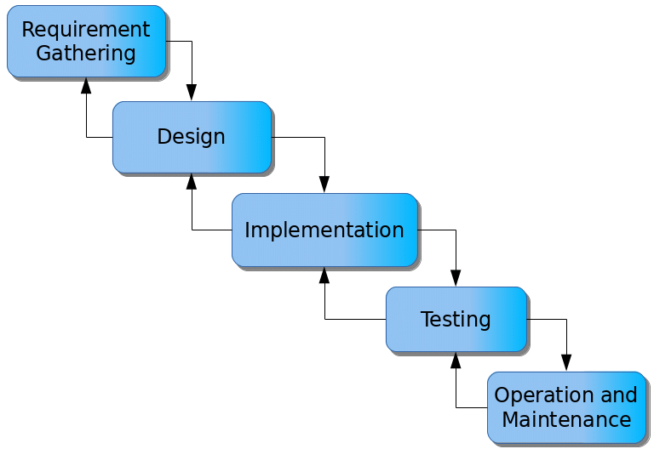

Figure 3.1: Waterfall model

**Requirement Stage:** During this stage, all possible system requirements were documented in a requirements document. This stage requires technical expertise and knowledge that personnel will use in operating the proposed application.

**Design Stage:** In this phase, high-level and low-level designs were prepared. The software design was created to verify the authenticity of the applications and ensure a seamless user experience.

**Development Stage:** In the Development phase, the software development team started coding and developing the software. This is the longest phase of the Waterfall Model as developers need more time to build the software. Once the development of the software is completed, the project is handed over to the testers.

**Testing Stage:** The software is developed and then tested to ensure it runs successfully. The researcher will ensure that the end-to-end software is complete and functional.

**Deployment Stage:** Once the software has been successfully tested, it is deployed to become live for real-time users. The deployment phase makes the application available to students and administrative staff.

**Maintenance Stage:** After deployment, the application enters the maintenance phase. Clients usually require a maintenance period of one or two years to address any bugs or to implement slightly enhanced features as needed.

## 3.5 Method of Data Collection

Data collection for the development of the ID Card generating system with QR code included both primary and secondary sources. Primary sources include direct interactions with stakeholders, such as interviews and surveys, to gather requirements and feedback. Secondary sources encompass existing literature, research, and relevant documentation related to online application systems and system development.

## 3.6 System Design

System design for the ID Card generating system with QR code involves defining the platform's architecture, modules, interfaces, and data structures to meet specified requirements. It entails the application of systems theory to product development, ensuring the alignment of design elements with the objectives and needs of the ID Card generating system with QR code.

## 3.6.1 Algorithm Diagram

Use case diagram: A use case diagram shows the system and the various ways that users interact with the system.

Login

Add Bulk Student

Add Student

Print ID Card

Admin

Print Bulk ID

Log out

Print report

Figure 3.2: Use case diagram

## 3.6.2 System Architecture

**ADMIN**

**ID CARD PROCESSING SYSTEM WITH QR CODE**

System Database

Figure 3.3: System Architecture

## 3.6.3 Database Tables/Queries Structures

**Table 3.1: Students Details**

**Top of Form**

| **Name** | **Type** | **Extra** |
| --- | --- | --- |
| id Primary | int(11 | AUTO_INCREMENT |
| Name | varchar(50) |  |
| Department | varchar(255) |  |
| Level Index | varchar(50) |  |
| Matric No | varchar(50) |  |
| Passport | varchar(50) |  |
| Phone number | varchar(50) |  |

**Table 3.2: Admin Records**

Top of Form

| **Name** | **Type** | **Extra** |
| --- | --- | --- |
| id Primary | int(11) | AUTO_INCREMENT |
| First name | varchar(20) |  |
| Surname | varchar(20) |  |
| Email | varchar(50) |  |
| Password | varchar(50) |  |
| Phone | varchar(50) |  |

Bottom of Form

## 3.6.4 Input and Output Design

**ADD STUDENT**

Surname

Registration Number

Phone number

**SUBMIT**

First Name

Level

Department

**CLOSE**

Figure 3.4: Add Student Form

**LOGIN**

**LOGIN**

**LOGIN**

Email address

Password

Figure 3.5: Login form

**BULK PRINT**

FROM:

TO:

**SUBMIT**

Figure 3.6: Bulk Print

| **Student Name** | | **Registration Number** | | **Phone Number** | | **Department** | | **Level** | |
| --- | --- | --- | --- | --- | --- | --- | --- | --- | --- |
| KPONKIUS JAKE | | ST/CS/ND/22/002 | | kponkius@gmail.com | | COMPUTER SCIENCE | | ND1 | |
| KPONKIUS JACOB | | ST/CS/ND/22/003 | | kponk@gmail.com | | COMPUTER SCIENCE | | HND1 | |
| AKAMSHU JACOB | | ST/CS/ND/22/003 | | kponk@gmail.com | | COMPUTER SCIENCE | | HND1 | |
| INUSA SARAYA | | ST/CS/ND/22/005 | | ndbhalerao91@gmail.com | | COMPUTER SCIENCE | | ND | |
| 5 | JAMES JOHN | | ST/CS/HND/22/003 | | 08023123404 | | COMPUTER SCIENCE | | HND | |

Showing 1 to 5 of 5 entries

Figure 3.7: Student Report



The bearer whose photograph appears overleaf is a staff of

THE FEDERAL POLYTECHNIC, MUBI

If lost and found please return to the Security Unit, Federal Polytechnic, Mubi, Adamawa State

**THE FEDERAL POLYTECHNIC, MUBI**

**AKAMSHU JACOB**

Level:

**HND1**

Matric No:

**ST/CS/ND/22/003**

Department:

**COMPUTER SCIENCE**



Figure 3.8:ID Card report

## 3.7 System Requirements Specification

## 3.7.1 Hardware Requirements

The software to be design needs the following hardware for an effective operation of the newly designed system.

1. A system running on intel, P(R) duo core with higher processor
2. The-Random Access Memory (RAM) should be at least 512MB.
3. At least 20-GB hard disk.
4. A monitor.

## 3.7.2 Software Requirements

The software requirements include:

1. A window 7 or higher version of operating system.
2. XAMP or WAMP for Database
3. PHP
4. MySQL
5. Browser

## 3.7.3 Personnel Requirement

Any computer literate who has a technical knowhow of internet surfing can use the system because it is user friendly.

# CHAPTER FOUR

# RESULTS AND DISCUSSION

## 4.1 Introduction

This chapter presents the results and discussions of the newly developed system, which utilizes PHP and MySQL for efficient record insertion and updating. The system is designed to streamline the management and retrieval of information, thereby enhancing operational efficiency.

## 4.2 Results

**4.2.1 Welcome Interface**

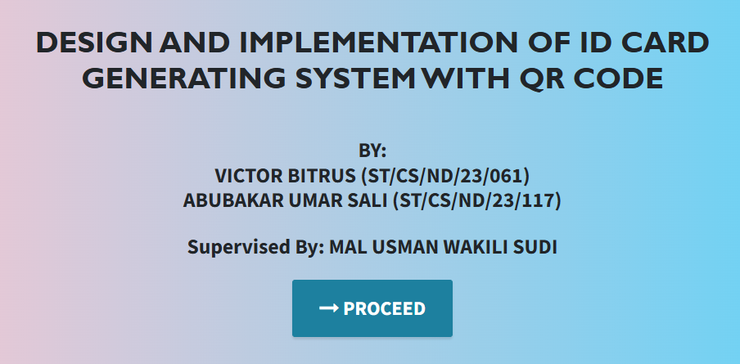

Figure 4.1: Welcome Interface

Figure 4.1 shows the welcome page of the ID Card Generating system. The welcome page is the first page that displays the project topic and the researchers.

**4.2.2 Login interface**

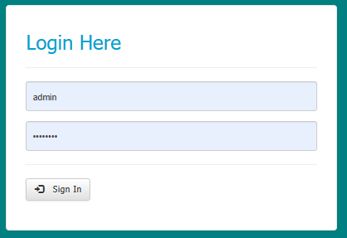

Figure 4.2: Login interface

Figure 4.2 above represents the user interface and workflow for gaining access into the system by entering the username and password.

**4.2.3 Add Students Details**

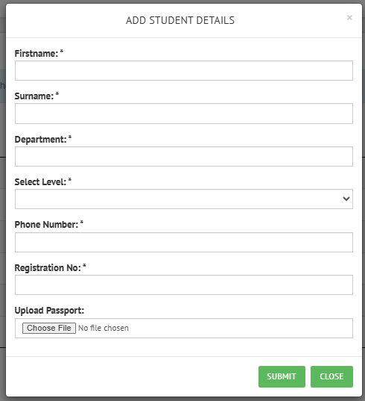

Figure 4.3: Add Student Details

Figure 4.3 above shows where a new student details can be added into the system using information such as first name, surname, department, level etc.

**4.2.4 Students Records Interface**

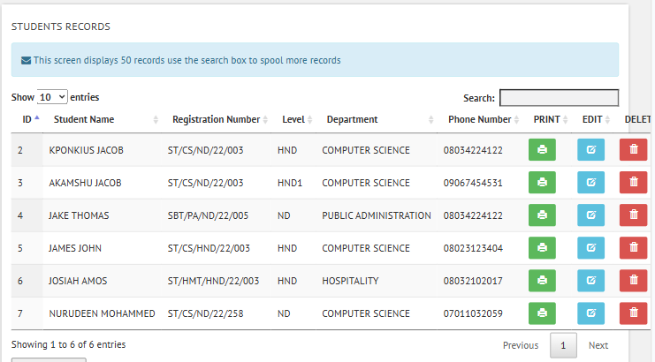

Figure 4.4: Students Records Interface

Figure 4.4 shows the records of all the students currently in the system where an ID card can be printed for a particular student.

**4.2.5 Print Bulk**

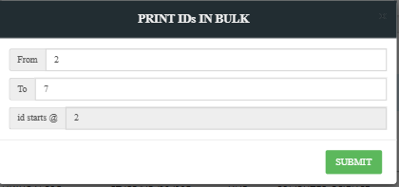

Figure 4.5: Print Bulk Interface

Figure 4.5 shows the interface used for printing bulk ID cards by inputting the range of the ID card to be printed.

**4.2.6 ID Card interface**

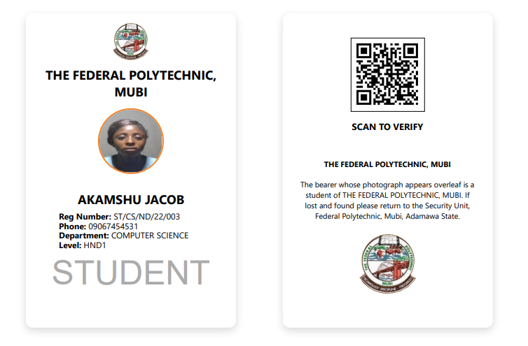

Figure 4.6: ID Card interface

Figure 4.6 above shows the result of the interface for the processed ID card to be printed.

## 4.3 Discussion

The Welcome Interface is the initial screen users encounter when they access the computerized student ID card processing system. It serves as the gateway to the system, providing users with a friendly and intuitive interface. The design typically includes the institution's logo, name, and a brief welcome message. Users can navigate to the login page or access informational sections about the system. The interface is designed to be visually appealing and easy to use, ensuring a positive first impression and guiding users seamlessly into the system's functionalities.

The Login Interface is a secure access point where authorized users, such as administrators and staff, can enter their credentials to access the system. It typically requires a username and password, with additional security features such as CAPTCHA or two-factor authentication to prevent unauthorized access. Upon successful login, users are granted access to the system's main features, including student record management and ID card processing. The interface emphasizes security and user-friendliness, ensuring that only authorized personnel can access sensitive student information.

The "Add Students Details" interface allows administrators to input new student information into the system. This interface includes fields for entering essential data such as student name, matriculation number, department, course of study, and contact details. It may also include options for uploading a student's photograph, which will be used on the ID card. The interface is designed to be straightforward, with validation checks to ensure that all required information is accurately entered. This feature is crucial for maintaining an up-to-date database of student information within the system.

The Students Records Interface provides a comprehensive view of all student information stored within the system. Authorized users can search, view, and manage student records through this interface. It includes features for editing or updating student details, deleting records, and viewing the history of changes made to each record. The interface is designed for efficiency, allowing quick access to student information, which is essential for the smooth processing and issuance of ID cards.

The "Print Bulk" interface is designed to facilitate the mass production of student ID cards. This interface allows administrators to select a group of students, such as an entire department or batch, and print their ID cards in bulk. Options for customizing the ID card layout, selecting specific fields to display, and configuring print settings are available. The interface streamlines the printing process, reducing the time and effort required to produce large quantities of ID cards, which is particularly useful during peak registration periods.

The ID Card Interface is where the actual design and layout of the student ID cards are managed. Administrators can use this interface to customize the appearance of the ID cards, including the placement of the student photo, institution logo, and text fields such as name and matriculation number. The interface provides a preview of the ID card, allowing users to make adjustments before finalizing the design. This feature ensures that all ID cards are consistently designed according to the institution's standards and can be efficiently printed or reprinted as needed.

## 4.4 User manual

## 4.4.1 System Installation

The user manual is a clear and precise instruction on how a user can operate the propose system, without any stress and successful. The following steps required

1. Start or boot the computer form the hard disk
2. Double click on the folder that program is been stored in the desktop
3. Double click on the program and allow it to load gently
4. A security unit will display were the user will specify the username and password the click on OK.
5. A welcome menu will be displayed where the user has options to select which operation to be performed.
6. To find information about player, select any name and search.
7. Click on exist on the welcome screen to exist from the program.

## 4.4.2 System operational guide

The following are the necessary steps to take in order to use the system efficiently and effectively.

1. Load the url of the system <https://localhost/idcard/> the welcome page will be displayed.
2. Click on the **Proceed** button to proceed to the main system.
3. If you created an account, provide your login details by entering your username and password.
4. Depending on the login details provided you will be automatically directed to the dashboard.
5. The various task that you can perform on the portal will be displayed on the sidebar of the dashboard.

# CHAPTER FIVE

# SUMMARY, CONCLUSION AND RECOMMENDATIONS

## 5.1 Summary

This project focused on the design and implementation of a computerized student ID card processing system for the Federal Polytechnic, Mubi. The study was motivated by the need to enhance the efficiency and accuracy of student ID card issuance, which is a critical aspect of student administration. The system was designed to address common challenges associated with manual ID card processing, such as delays, errors in student information, and difficulties in managing large volumes of data.

The system consists of several key interfaces, including the Welcome Interface, Login Interface, Add Students Details, Students Records Interface, Print Bulk, and ID Card Interface. Each interface was designed with user-friendliness and functionality in mind, ensuring that the system is easy to navigate for both administrators and staff. The system's implementation involved the use of modern software development techniques, ensuring that it is robust, scalable, and secure.

Overall, the project successfully met its objectives, providing a streamlined and automated solution for managing student ID card processing at the Federal Polytechnic, Mubi.

## 5.2 Conclusion

The computerized student ID card processing system developed in this project has proven to be an effective tool for enhancing the management of student identification at the Federal Polytechnic, Mubi. By automating the process, the system reduces the time and effort required to issue ID cards, minimizes errors in student records, and improves the overall efficiency of the institution's administrative processes. The successful implementation of this system demonstrates the potential of technology to address challenges in educational administration, making it a valuable asset to the institution.

## 5.3 Recommendations

Based on the findings and outcomes of this project, the following recommendations are made:

1. It is recommended that the Federal Polytechnic, Mubi, fully adopt the system across all departments to standardize the ID card issuance process and improve administrative efficiency.
2. Adequate training should be provided to all staff members who will be using the system to ensure they are familiar with its features and functionalities. Ongoing technical support should also be available to address any issues that may arise.
3. The institution should plan for regular updates and maintenance of the system to ensure it remains secure and up-to-date with technological advancements. This will help to maintain the system's reliability and performance over time.
4. Given the sensitive nature of student information, it is essential to implement robust data security measures to protect against unauthorized access and data breaches.

# REFERENCES

Alharthi, M., Al-Emran, M., & Al-Rahmi, W. M. (2020). The role of digital transformation in higher education institutions: A systematic review. *IEEE Access, 8*, 144450-144467. https://doi.org/10.1109/ACCESS.2020.3011328

Alotaibi, B., Alotaibi, H., & Albatti, A. (2021). Enhancing security in educational institutions through biometric authentication systems. *Journal of Information Security and Applications, 58*, 102772. https://doi.org/10.1016/j.jisa.2021.102772

Azeez, S., Khalid, A., & Yusuf, M. (2022). Future-proofing educational administration: The role of adaptable and scalable information systems. *Journal of Educational Technology & Society, 25*(2), 1-14.

Davis, J., & Wong, R. (2021). Student expectations and experiences with digital administrative services in higher education. *Journal of Educational Administration, 59*(5), 538-555. https://doi.org/10.1108/JEA-03-2020-0034

Denning, P. J. (2017). Design science in information systems. *Communications of the ACM, 60*(8), 36-43. https://doi.org/10.1145/3084041

Ferdousi, F., Karim, M. R., & Chowdhury, S. M. (2020). Impact of computerized systems on the administrative efficiency of educational institutions. *Journal of Education and Practice, 11*(9), 65-73. https://doi.org/10.7176/JEP/11-9-08

Gonzalez, R., Oliveira, J., & Silva, M. (2019). Methodologies for evaluating the performance of computerized ID card systems. *International Journal of Information Management, 45*, 16-25. https://doi.org/10.1016/j.ijinfomgt.2018.10.008

Hevner, A. R. (2014). A three-cycle view of design science research. *Scandinavian Journal of Information Systems, 26*(2), 87-92.

Johnson, M., & Roberts, P. (2021). Improving accuracy and efficiency in student ID card processing: A computerized approach. *Journal of Educational Technology Research and Development, 69*(4), 2041-2056. https://doi.org/10.1007/s11423-021-09982-2

Kim, S., & Park, Y. (2019). Environmental benefits of digital solutions in educational administration. *Sustainability, 11*(20), 5753. https://doi.org/10.3390/su11205753

Laudon, K. C., & Laudon, J. P. (2020). *Management information systems: Managing the digital firm* (16th ed.). Pearson.

Liu, W., & Huang, R. (2019). User-centric design in computerized ID card systems: Enhancing satisfaction and adoption. *Journal of Systems and Software, 157*, 110397. https://doi.org/10.1016/j.jss.2019.07.022

Lunenburg, F. C. (2021). Management concepts and organizational behavior. *International Journal of Management, Business, and Administration, 24*(1), 1-14.

Marques, G., Pitarma, R., & Garcia, N. (2020). Mobile ID solutions in educational institutions: Trends and challenges. *Education and Information Technologies, 25*(3), 1-15. https://doi.org/10.1007/s10639-020-10157-4

Rahman, M., & Hossain, M. S. (2022). Leveraging AI in computerized ID card systems for enhanced security. *Journal of Artificial Intelligence Research, 73*, 521-536. https://doi.org/10.1613/jair.1.12294

Rodrigues, P., Silva, A., & Oliveira, M. (2018). The impact of computerized systems on administrative efficiency in educational institutions. *Computers & Education, 122*, 1-9. https://doi.org/10.1016/j.compedu.2018.03.001

Rocha, R., Ferreira, A., & Gonçalves, P. (2021). Integration of ID card systems with institutional databases for improved resource utilization. *Journal of Information Systems and Technology Management, 18*(3), 450-465. https://doi.org/10.4301/S1807-17752021000300009

Saini, R., & Grewal, R. (2020). RFID technology in computerized ID card systems: Enhancing operational efficiency. *Journal of Industrial Information Integration, 18*, 100149. https://doi.org/10.1016/j.jii.2020.100149

Simon, H. A. (2016). *The sciences of the artificial* (3rd ed.). MIT Press.

Smith, J., Brown, K., & Wilson, L. (2019). Security enhancements in computerized systems for educational institutions. *Journal of Computer Security, 27*(4), 615-632. https://doi.org/10.3233/JCS-191227

Tsolakidis, A., & Kartakoullis, N. L. (2019). Real-time data analytics in educational institutions: Improving decision-making and efficiency. *Computers & Education, 137*, 65-78. https://doi.org/10.1016/j.compedu.2019.04.010

Wang, S., Zhang, Y., & Liu, H. (2021). Blockchain technology for secure ID verification systems in educational institutions. *Journal of Network and Computer Applications, 177*, 102920. https://doi.org/10.1016/j.jnca.2021.102920

Yi, Y., & Hwang, J. (2018). Enhancing service quality and student satisfaction through computerized systems in higher education. *Journal of Hospitality and Tourism Management, 34*, 33-42. https://doi.org/10.1016/j.jhtm.2017.12.002

# APPENDIX A

Welcome interface



Login interface



Add Students Details



Students Records Interface



Print Bulk



ID Card interface



# APPENDIX B

**PROGRAM CODE**

<!DOCTYPE html>

<html lang="en">

<head>

<meta charset="utf-8">

<meta name="viewport" content="width=device-width, initial-scale=1, shrink-to-fit=no">

<meta name="description" content="">

<meta name="author" content="">

<title>DESIGN AND IMPLEMENTATION OF COMPUTERIZED STUDENT ID CARD PROCESSING SYSTEM </title>

<!-- Bootstrap Core CSS -->

<link href="vendor/bootstrap/css/bootstrap.min.css" rel="stylesheet">

<!-- Custom Fonts -->

<link href="vendor/font-awesome/css/font-awesome.min.css" rel="stylesheet" type="text/css">

<link href="https://fonts.googleapis.com/css?family=Source+Sans+Pro:300,400,700,300italic,400italic,700italic" rel="stylesheet" type="text/css">

<link href="vendor/simple-line-icons/css/simple-line-icons.css" rel="stylesheet">

<!-- Custom CSS -->

<link href="css/stylish-portfolio.min.css" rel="stylesheet">

</head>

<body id="page-top" style=" background: linear-gradient(90deg, pink, rgb(67, 207, 250));">

<!-- Header -->

<header class="masthead d-flex">

<div class="container text-center">

<h1 class="mb-2" style="font-size: 45px; font-weight: bolder; font-family: 'Gill Sans', 'Gill Sans MT', Calibri, 'Trebuchet MS', sans-serif; text-transform: uppercase;"><span style=" margin-top:15px;"> DESIGN AND IMPLEMENTATION OF COMPUTERIZED STUDENT ID CARD PROCESSING SYSTEM </span> <br> </h1>

<h2 class="mb-3" style=""> (case study of Federal Polytechnic, Mubi)</h2><br><br>

<h2>BY: <br>ABDULHAMID ABUBAKAR (ST/CS/ND/22/065) <br>NURUDEEN MOHAMMED (ST/CS/ND/22/257) <br>HALILU SHAMSUDDEEN (ST/CS/ND/22/449)</h2> <br>

<h2> Supervised By: ANA ATICHA JACOB</h2>

</h3>

<br>

<strong><a class="btn btn-primary btn-xl js-scroll-trigger" href="card/" style="font-size: 30px;"><span class="fa fa-long-arrow-right"></span> PROCEED</a></strong>

<br> <br> <br>

<!-- <h4 class="alert alert-success"><a href="onlinefood-order/admin/index.php">Admin Login Here!</a></h4> -->

</div>

<div class="overlay"></div>

</header>

<!-- Scroll to Top Button-->

<a class="scroll-to-top rounded js-scroll-trigger" href="#page-top">

<i class="fa fa-angle-up"></i>

</a>

<!-- Bootstrap core JavaScript -->

<script src="vendor/jquery/jquery.min.js"></script>

<script src="vendor/bootstrap/js/bootstrap.bundle.min.js"></script>

<!-- Plugin JavaScript -->

<script src="vendor/jquery-easing/jquery.easing.min.js"></script>

<!-- Custom scripts for this template -->

<script src="js/stylish-portfolio.min.js"></script>

</body>

</html>

<?php

include_once("db_connect.php");

$sqluse ="SELECT * FROM Inorg WHERE id=1 ";

$retrieve = mysqli_query($db,$sqluse);

    while($foundk = mysqli_fetch_array($retrieve))

         {

              $name = $foundk['name'];

              $website = $foundk['website'];

         }

?>

<!DOCTYPE html>

<html>

<head>

<meta http-equiv="Content-Type" content="text/html; charset=utf-8" />

<script src="https://ajax.googleapis.com/ajax/libs/jquery/2.1.3/jquery.min.js"></script>

<script src="https://maxcdn.bootstrapcdn.com/bootstrap/3.3.5/js/bootstrap.min.js"></script>

<link rel="stylesheet" href="https://maxcdn.bootstrapcdn.com/bootstrap/3.3.5/css/bootstrap.min.css">

<link rel="stylesheet" href="https://maxcdn.bootstrapcdn.com/bootstrap/3.3.5/css/bootstrap-theme.min.css">

<link rel="stylesheet" href="https://cdnjs.cloudflare.com/ajax/libs/x-editable/1.5.0/bootstrap3-editable/css/bootstrap-editable.css">

<script src="https://cdnjs.cloudflare.com/ajax/libs/x-editable/1.5.0/bootstrap3-editable/js/bootstrap-editable.min.js"></script>

<title>

    <?php if(isset($website)){echo$website;}?>

</title>

<script type="text/javascript" src="script/validation.min.js"></script>

<script type="text/javascript" src="script/login.js"></script>

<script src="script/sweetalert.min.js"></script>

<link rel="stylesheet" type="text/css" href="script/sweetalert.css">

<link href="css/style1.css" rel="stylesheet" type="text/css" media="screen">

    <!-- <link rel="stylesheet" href="style.css"> -->

</head>

<body class="" style="background-color:#008080">

<div role="navigation" class="navbar navbar-default navbar-static-top">

      <div class="container">

        <div class="navbar-collapse collapse">

          <ul class="nav navbar-nav">

            <li class="active"><a href="#"> <?php if(isset($name)){echo$name;}?></a></li>

          </ul>

        </div><!--/.nav-collapse -->

      </div>

    </div>

    <div class="container" style="min-height:500px;">

    <div class=''>

    </div>

           <div class="container">

    <h2></h2>

    <form class="form-login" method="post" id="login-form">

        <h2 class="form-login-heading">Login Here</h2><hr />

        <div id="error">

        </div>

        <div class="form-group">

            <input type="email" class="form-control" placeholder="Email address" name="user_email" id="user_email" />

            <span id="check-e"></span>

        </div>

        <div class="form-group">

            <input type="password" class="form-control" placeholder="Password" name="password" id="password" />

        </div>

        <hr />

        <div class="form-group">

            <button type="submit" class="btn btn-default" name="login_button" id="login_button">

            <span class="glyphicon glyphicon-log-in"></span> &nbsp; Sign In

            </button>

        </div>

    </form>

</div>

<div class="insert-post-ads1" style="margin-top:20px;">

</div>

</div>

</body>

</html>